Algorithm of lost NPC
It is probed by Wohlstand 19 Feb 2017

As we know that if usual NPC leaves for visibility limits, it "will be lost". It will return on an initial position as soon as the initial position will appear out of a visibility range of the player.
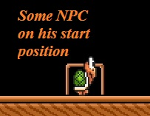
But apparently, not all NPCs can be lost, and they remain on the same position even out of a visibility range of the player and remain there, or move across the field depending on algorithm of NPC.

For all NPC, a loss timeout - 4 seconds out of visibility of the player.

Мay be lost: NPC enemies and NPC items which have been kicked out from the block. But sometimes NPC-items aren't lost. NPC-items if they were in the field out of the block aren't lost. If NPC-item was lost, it is lost forever. NPC-boss (Bowser 1 and Bowser 2, Wart, Mouser) can't be lost. After activation, it is active to the most death. NPC-vines aren't lost. The NPC generator isn't lost.

All NPC which are from the moment of start of game behind visibility limits of the player, aren't active. At emergence in a visibility range of the player, NPC becomes more active.

Detal demonstration of this alhorytm:
http://www.youtube.com/watch?v=8R0OaORZY54

